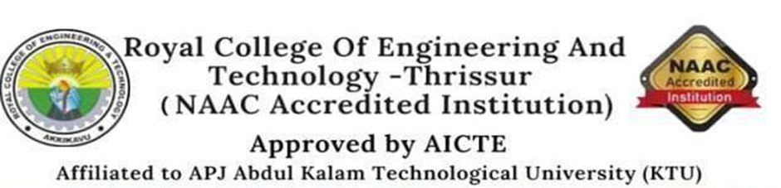
INTERNATIONAL CONFERENCE ON EMERGING TECHNOLOGIES
ICET 2022
Royal College of Engineering and Technology organized a two-day International conference on emerging technologies with the theme; Envisage the future on 16th and 17th of September. ICET 2022 aimed to explore advanced ideas and technologies in a wider range in the form of presentations and discussions with eminent personalities in terms of experience and experts. The conference explored technical science and emerging technologies. UG, PG, research scholars and faculties were invited to present papers.
The conference was inaugurated on 16th September 2022 by Mr. V P Salim, CEO, RCET. The programme beginned at 9.30 AM with a prayer. Dr. N Muthukumaran, Convenor of ICET 2022, HOD, Department of Civil Engineering, welcomed the gathering. Dr. Devi V, Principal addressed the audience and conveyed wishes. The programme proceeded to the inaugural address by Salim sir, CEO.
It was followed by the sessions handled by two eminent persons, first session was by Dr K. G Smitha, Senior Lecturer, School of Computer Science and Engineering, Nanyang Technological University, Singapore on “Brain Computer Interface Systems : Overview and Applications ” and second session was by Dr. Chithirai Pon Selvan, Head of School, Science and Engineering, Curtin University, Dubai on the topic “ Engineering for Sustainable Development”.Then afternoon 2.30 to 3.30pm parallel sessions were conducted by each departments.
On 17th September each departments paper presentations were conducted from 9:30am. The 2 day conference ended up by valedictory session at 3pm on 17th.

