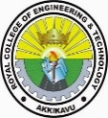ROYAL COLLEGE OF ENGINEERING AND TECHNOLOGY
Chiramanangad P.O., Akkikavu, Thrissur-680604
Ph: +91(4885) 289009, 271121, 271122
A NAAC Accredited Institution
Department of Computer Science and Engineering in association with R-AIM and CSI conducted a seminar on "Recent Trends in New Age Technologies" on 20/02/20223 (Monday). The event was scheduled from 2.00 pm to 4.00 pm . The seminar was delivered in two sessions: 2.00 pm to 3.00 pm for final year students and 3.00 pm to 4.00 pm for pre-final year students. The session was handled by Mr. Mithun Viswam, Aptech Academy, Thrissur. The session started with welcome address by Nahla (S8 CSE). About 43 final year students and 53 pre-final year students took part in the event.
The session mainly focussed on recent opportunities in IoT (Internet of Things) and also discussed certain career opportunities in the area of Data Analytics, Network and the Networking Structure, Security, Hardware and Devices, AI etc. Discussion was also done on the area of Data science, as it is among the most promising domains with ample of opportunities across different industries. The area comes as: Data Scientist, Data Analyst, Data Engineer, Data Architect etc. The session was concluded with an MCQ test conducted of which the academy provides fee reduction to the students for the above-mentioned courses. Few snaps of the event is being attached here.

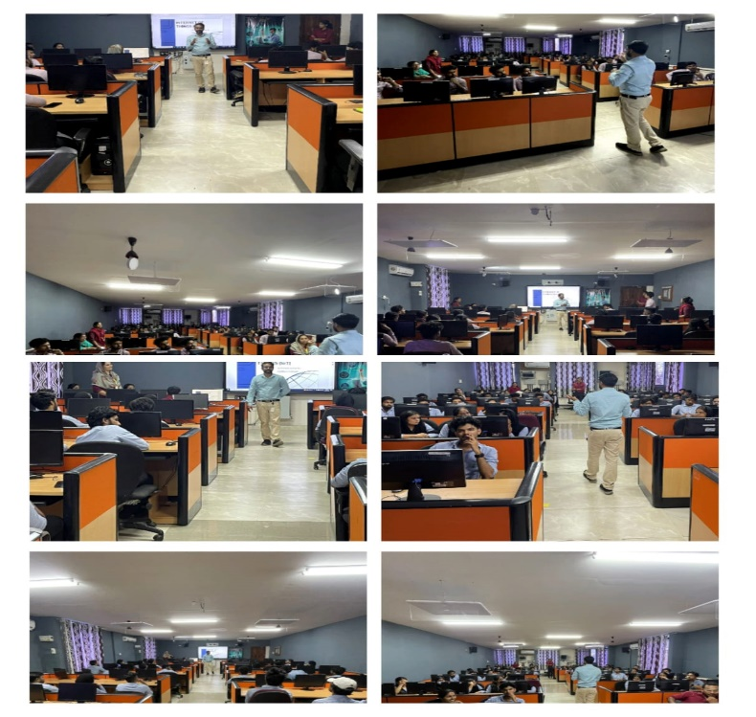
The program was very efficiently initiated and co-ordinated by student co-ordinators Ms Nahla (S8 CSE) and Mr Fayis (S8 CSE). The session ended with vote of Thanks delivered by Ms Neethu (S6 CSE). Student feedback was collected after the event. The session was very interactive and informative to the students.

