ROYAL ASSOCIATION FOR INTERACTION WITH MASTERS (RAIMS)
Dept. of Applied Electronics and Instrumentation Engineering
In connection with RAIMS, Department of Applied Electronics and Instrumentation organized a session on 10/10/2018, where an alumni of RCET Mr.Rahul H (Centre Manager, Livewire, Thrissur), interacted with the students of AEI. In his speech, he shared his experiences and motivated our students to update themselves with the recent advancements in the field of engineering. He also mentioned about the various internship programs offered by Livewire. As Livewire has more than 100 branches in India and across 6 countries, they assure job opportunities to freshers. He has also mentioned about the free internship course on Industrial Automation offered by Livewire for economically backward students and told our students to utilize this wonderful opportunity.

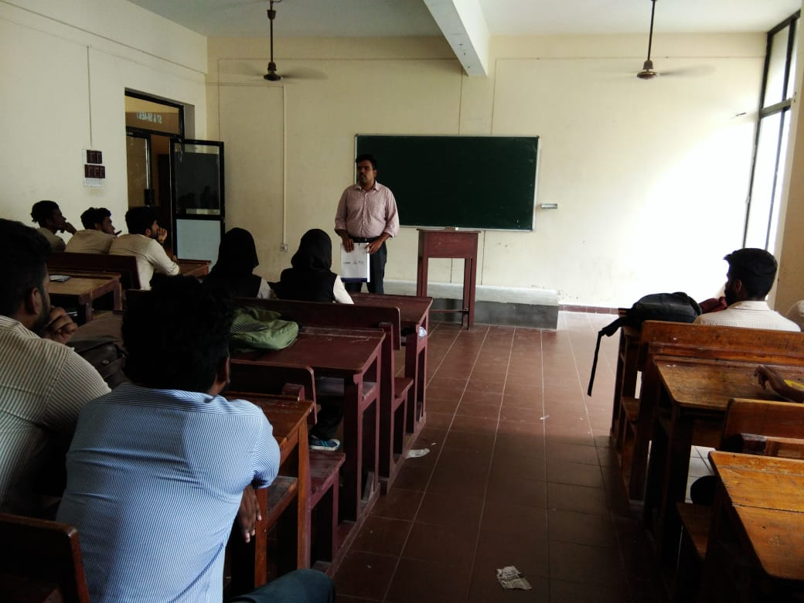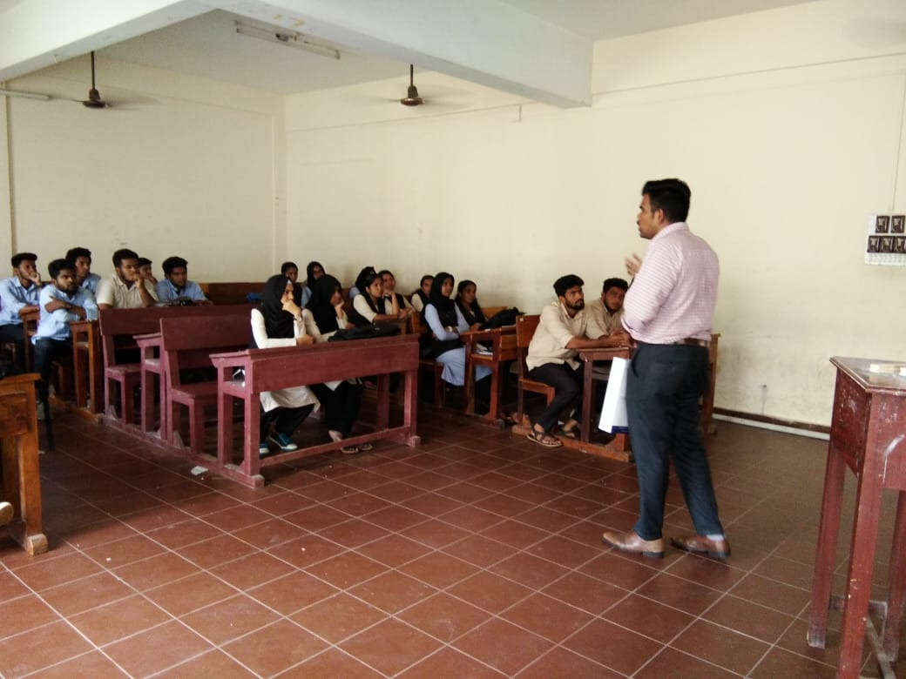

Venue: AEI Classroom, RCET
Date: 10/10/2018
RAIMS Dept. In-charge: Mr.Pradosh kumar P, Ms.Sruthi K Suresh

