RCET MEDICINAL GARDENS: AN OVERVIEW

A committee for building medicinal plants garden and its maintenance was formed at Royal College of Engineering and Technology Day on March 3rd 2021 with twelve staff members. The Royal college of Engineering and Technology has a medicinal plant garden in its beginning stage on an area of about 400 sqm in rectangular shape with 40 X 10 metres which is situated adjacent to the northern side of Mechanical block. Medicinal Fruits garden is situated at the rear side of Mechanical block (350 sqm).

RCET Medicinal plant garden and Medicinal Fruits garden are maintained by RCET Environmental Forum. The boundary of the garden is well demarcated with solid-bricks half walls and bordered with green nets. Various types of herbs, shrubs, and fruit saplings growing under shade have been planted in demarcated areas. All the plants present in the medicinal garden are protected from weeds. Proper water supply with the sprinkler, and enough sunlight is maintained with sufficient shade. We have been nurturing 40 herbal plants. Name boards, detailing the names of the plants are fixed. There is an arch built for our garden. We have moss rose garden also.

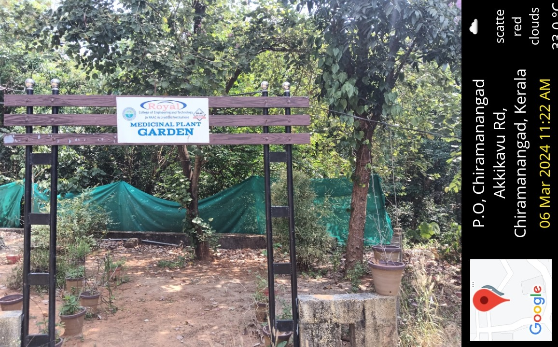

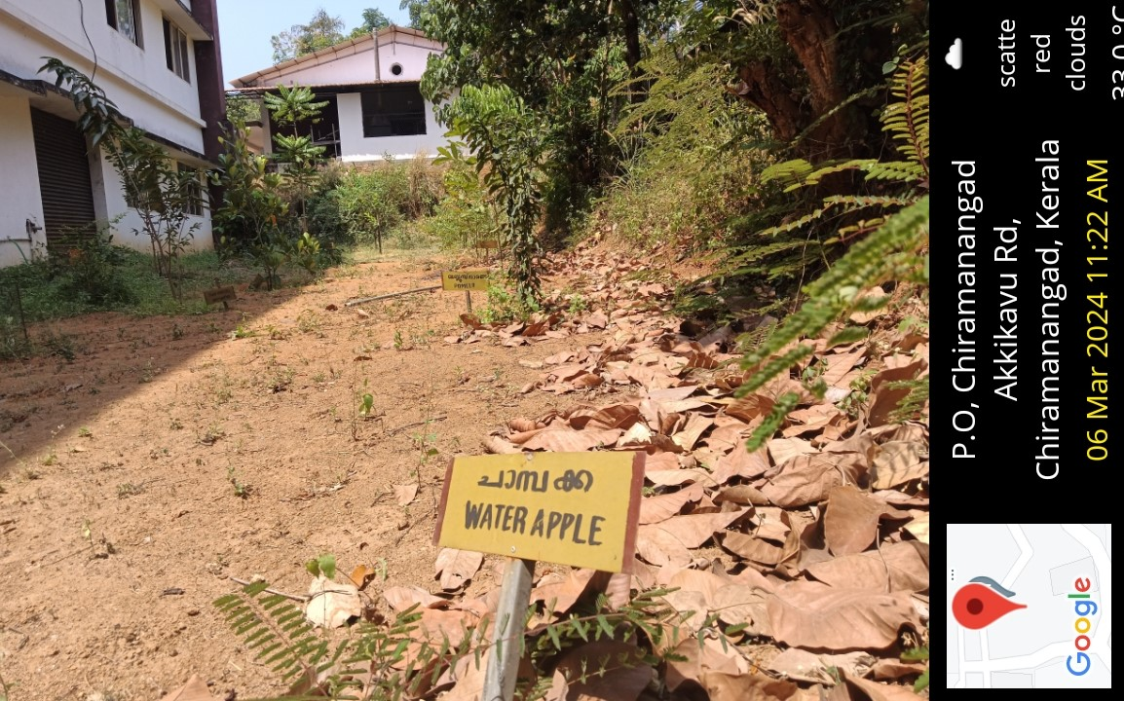

In addition to the Medicinal Garden, Royal College started a new venture in 2022, namely, a Medicinal Fruit Garden located behind the Mechanical Engineering block. The garden is maintained by gardening staff. A medicinal fruit garden offers a unique blend of health benefits and culinary delights. By cultivating a variety of fruits known for their medicinal properties, such as passion fruit rich in antioxidants or avocado with immune-boosting properties, one can easily incorporate these nutritious elements into their diet, promoting overall well-being. Additionally, maintaining such a garden provides an opportunity for sustainable and organic practices, ensuring the purity and potency of the fruits grown.

The following Medicinal fruit saplings has been grown there:

Guava
Rambutan
Sapota
Gooseberry
Mango
Water apple
Bablus
Orange
Lemon
Passion fruit
Rubika
Sita fruit
Papaya
Avocado
Arinelli
Mangosteen.

On October 1st 2022 (Gandhi Jayanti) A Cleaning Program of Medicinal gardens was conducted. The program was Inaugurated by Mr.Sree Kumar.C, Sub Inspector of Police, Kadangode.Mr. Sreekumar and Prof. Amrutha Chemmannur delivered a short speech.
Heads of the department and students actively participated in the program.

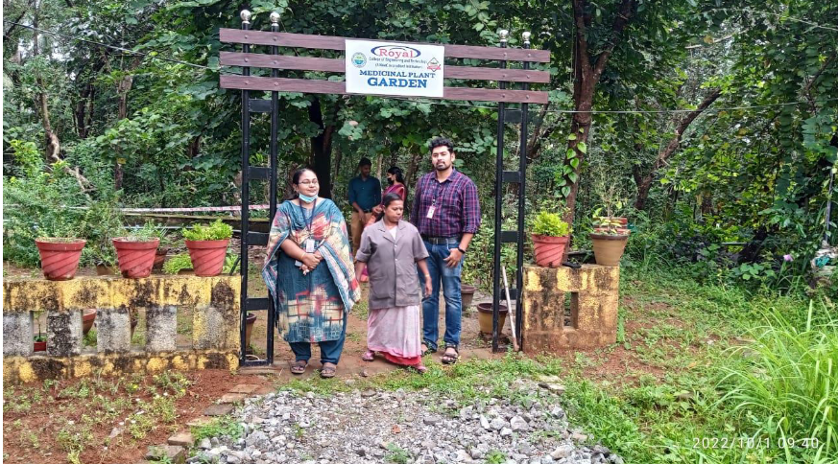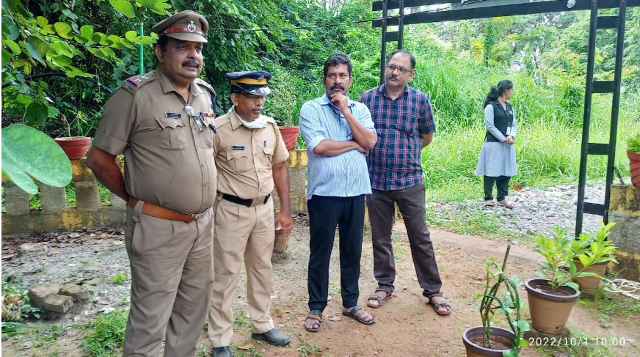

On October 29, 2022, a board was installed in the Medicinal Fruit Garden stating: "Built with the assistance of the Dr. Suvarna Nalappat Foundation.”

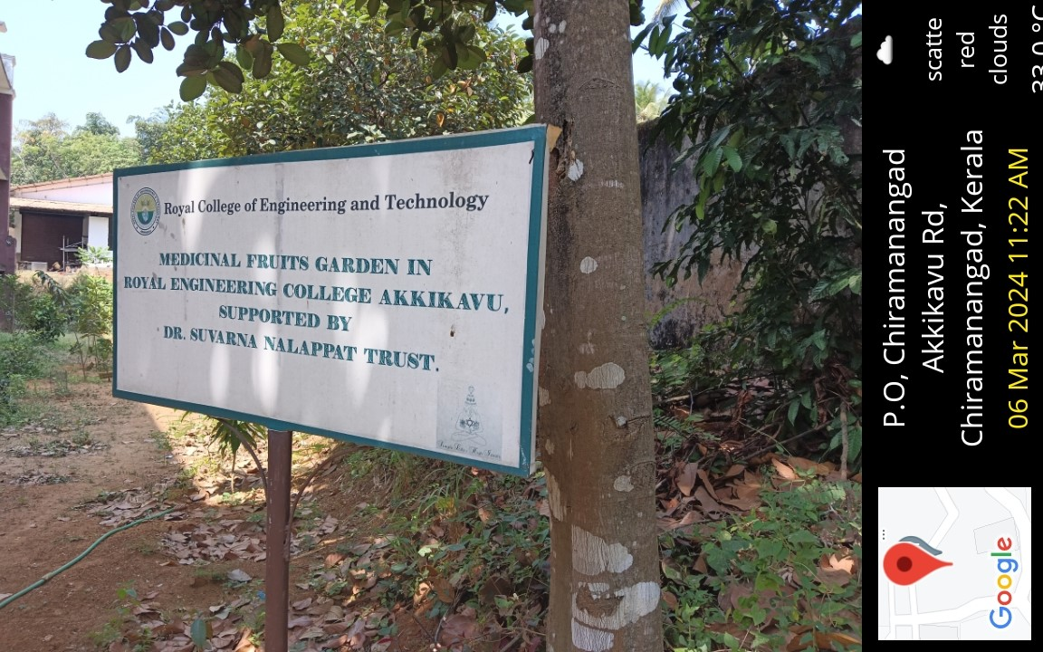

Second phase of the sapling planting program was inaugurated by College principal
Dr Devi.V on January 31st 2023.

Following staff members involved in planting saplings:

Mr.T.M Sankunny
Mr.Mani
Mr.Sudev.K
Dr.Ajmal
Mr.Sasi Kumar
Ms.Priya
Ms.Shanija
Ms.Haritha
Mr. Reji.
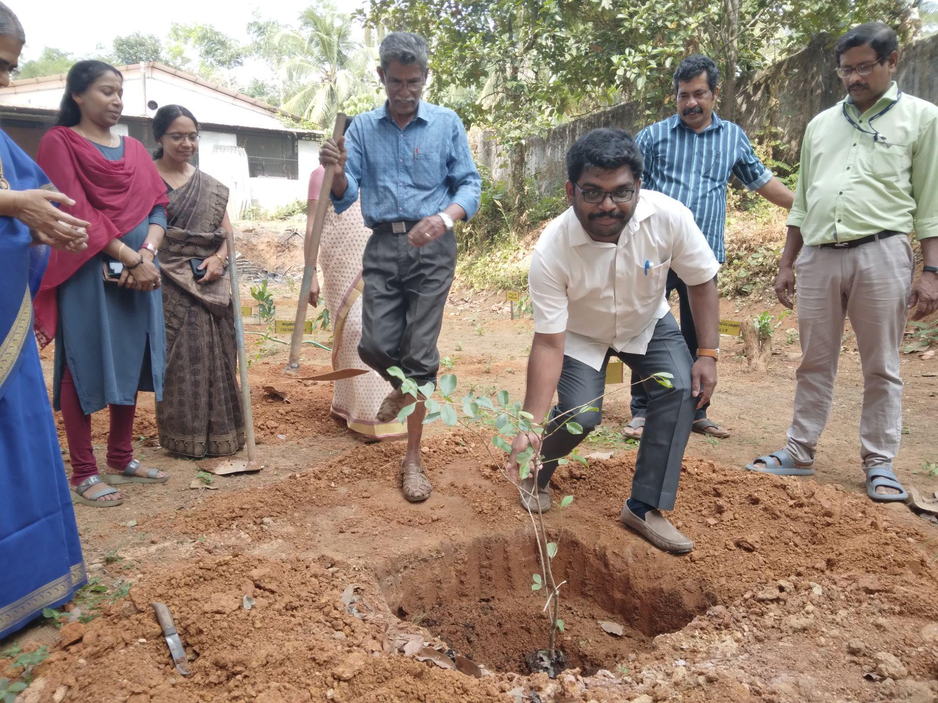

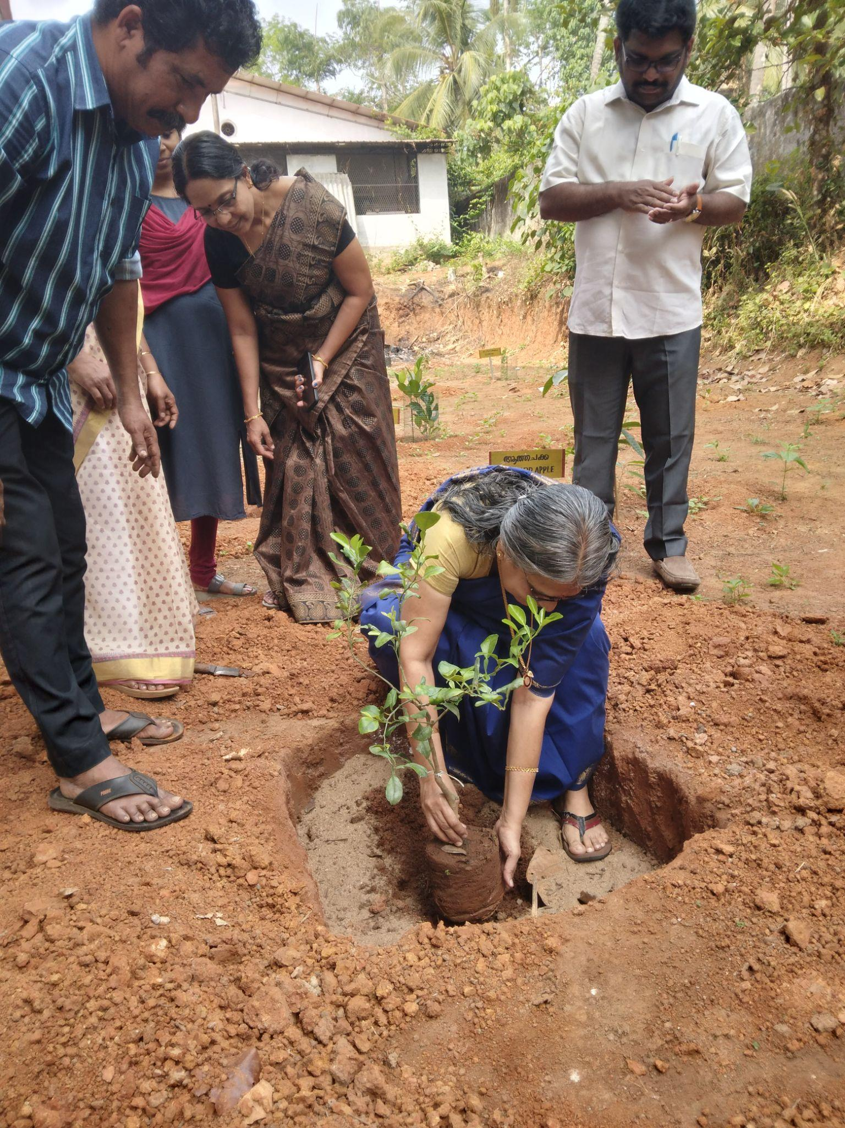

On January 16, 2023, Dr. Suvarna Nalapat handed over a check for Rs. 5000 for the maintenance and development of the RCET Medicinal Fruit Garden. The check was presented to Principal Dr. Devi V at Dr.Nalapat's residence.

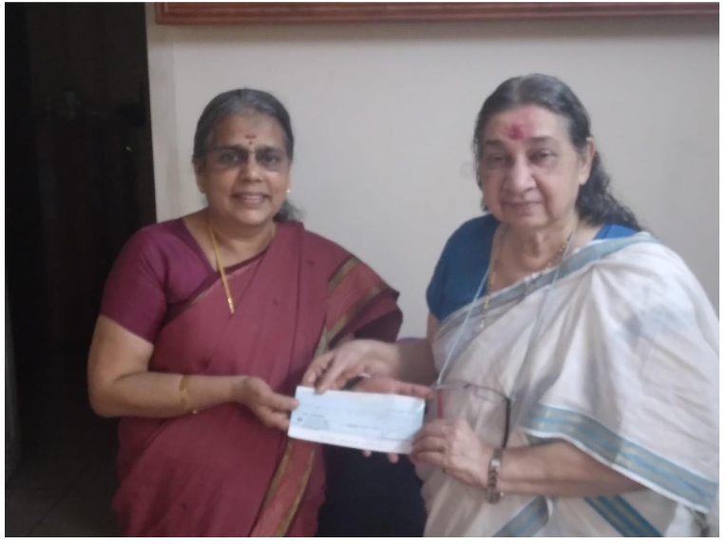

On May 1st 2023 Green net was placed as a fence for the protection of the medicinal garden. The net protects the garden from intruders such as wild boars, porcupines, peacocks etc.

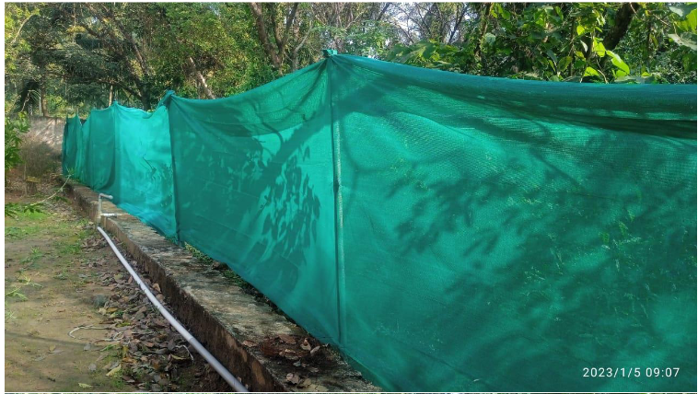

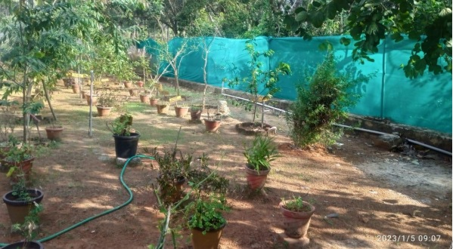

On June 5th, 2023, the Royal College of Engineering and Technology organised a World Environment Day event at the Royal Medicinal Garden. The event, conducted by the RCET Environmental Forum and inaugurated by Dr. Muthukumaran, Principal in charge, commenced with the planting of a sapling. College students actively participated in the program. Mr. Mani, Mr. Kumar, Mr. Chandran, Mr. Reji, Ms. Priya, and Ms. Shabana actively participated in the activities. The event aimed to promote environmental awareness and sustainability, with a welcome speech by convener Mr. T.M. Sankunny and a vote of thanks by Mr. Shashi Kumar expressing gratitude to all involved.
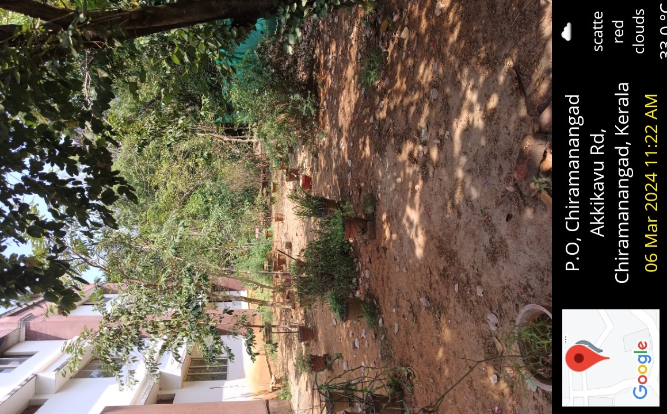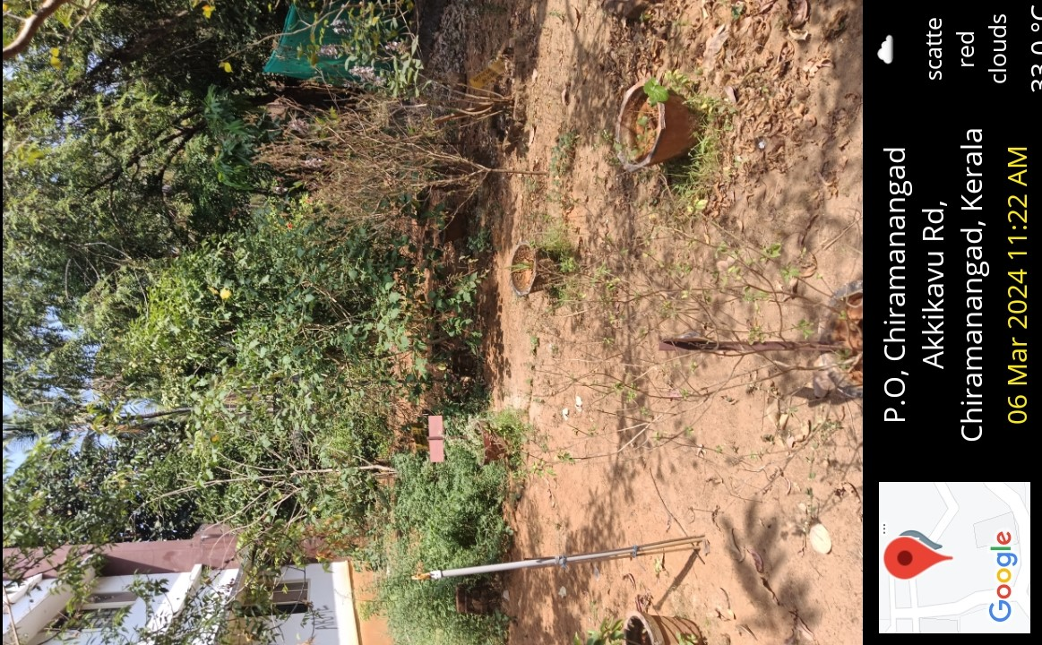
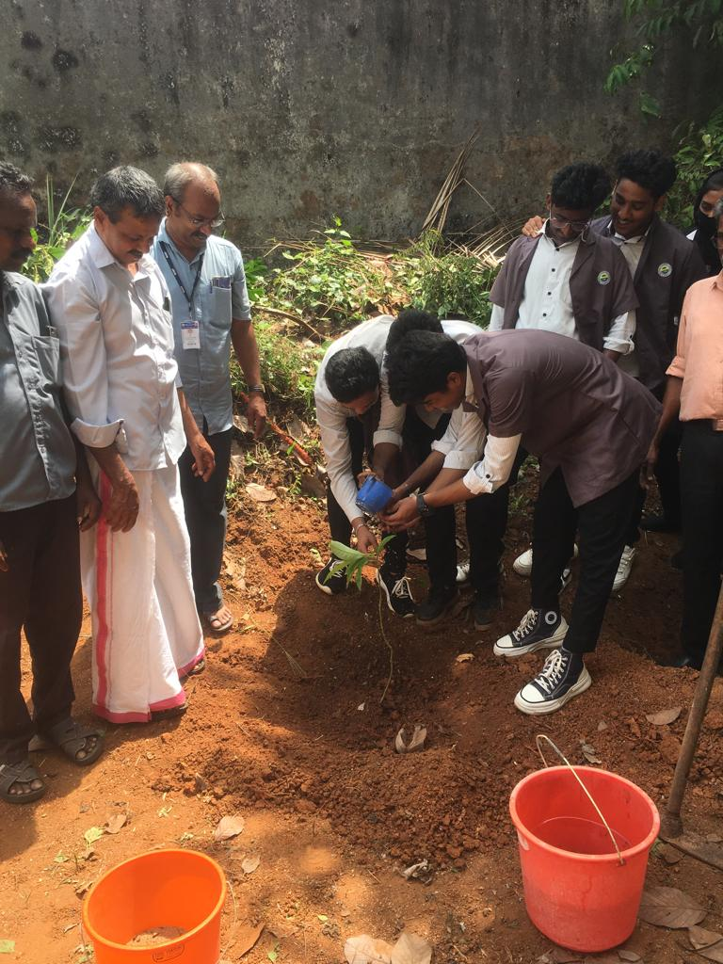

Weeding out the medicinal garden was carried out on September 27, 2023, with participation from staff members and students. The activity was headed by Dr. Zealakshmi, H.o.D - CE.




